J Squared Custom Tables Price List

Farmhouse Dining Tables Trestle Tables Square Tables
Up to 4’ long - $450 Up to 6’ long: $700 37”x37” - $500
Up to 6’ long - $600 Up to 8’ long: $800 46”x46” - $600
Up to 8’ long - $700 Up to 10’ long: $1000 55”x55” - $700
Up to 10’ long - $800 Up to 12’ long: $1200 66”x66” - $900
Up to 12’ long- $1000

Additional Options:
*Clear groove top $100
*End extensions add $100
*Breadboard ends: add $75
*Counter 36” and pub height 42”: add $50
*Outdoor finish: add $100/table $20/bench
Farmhouse and trestle tables are priced at 37” wide, add $50 for 45” wide.
Turned legs available please ask about price.
Matching Benches:
$180/bench up to 8’ long
$250/bench up to 10’ long (3 sets of legs)
jsquaredcustomtables@gmail.com
715-497-2899
1998 Hwy 65
New Richmond, WI 54017

J SQUARED CUSTOM TABLES CHAIR PRICE LIST

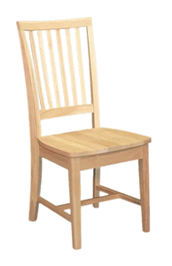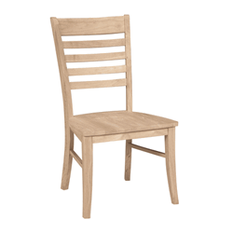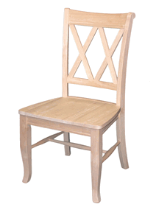

mission $160 roma $170 DOUBLE X BACK $170

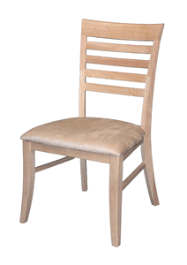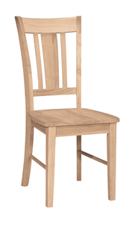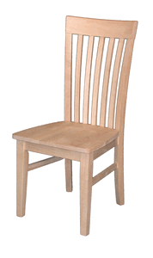

UPHOLSTERED ROMA $170 SAN REMO $155 TALL MISSION $170

We do not build chairs but they are all carefully selected solid wood and hand stained and finished for exceptional quality. (price per chair)

