J Squared Custom Tables Price List

Farmhouse Dining Tables Trestle Tables Square Tables
Up to 4’ long - $400 Up to 6’ long: $650 37”x37” - $450
Up to 6’ long - $550 Up to 8’ long: $750 46”x46” - $550
Up to 8’ long - $650 Up to 10’ long: $950 55”x55” - $650
Up to 10’ long - $750 Up to 12’ long: $1200 66”x66” - $800
Up to 12’ long- $950

Additional Options:
*Clear groove top $100
*End extensions add $100
*Breadboard ends: add $50
*Counter 36” and pub height 42”: add $50
*Outdoor finish: add $100/table $20/bench
Farmhouse and trestle tables are priced at 37” wide, add $50 for 45” wide.
Turned legs available please ask about price.
Matching Benches:
$150/bench up to 8’ long
$200/bench up to 10’ long (3 sets of legs)
jsquaredcustomtables@gmail.com
715-497-2899
1998 Hwy 65
New Richmond, WI 54017

J SQUARED CUSTOM TABLES CHAIR PRICE LIST

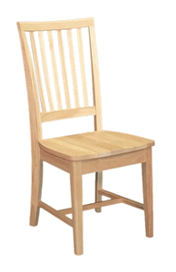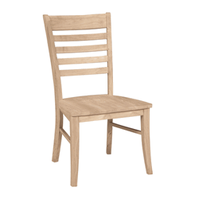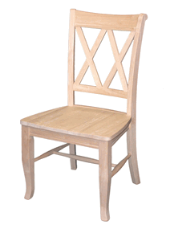

mission $160 roma $170 DOUBLE X BACK $170

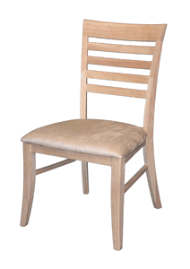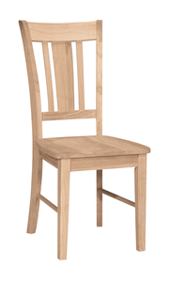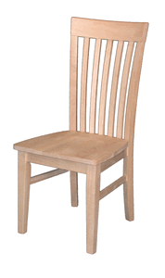

UPHOLSTERED ROMA $170 SAN REMO $155 TALL MISSION $170

We do not build chairs but they are all carefully selected solid wood and hand stained and finished for exceptional quality. (price per chair)

